

CE066 Jaydeep Mahajan

**AIM:** To synthesize images and add gaussian, salt and pepper and exponential noise to it.

**EXERCISE:**

1. **Synthesize the image of a chess board. (use intensity 50 for dark block and 170 for bright block). Add gamma noise and exponential noise (both separately) and generate noisy image. Show and comment on histogram of the noisy images.**

**Code:**

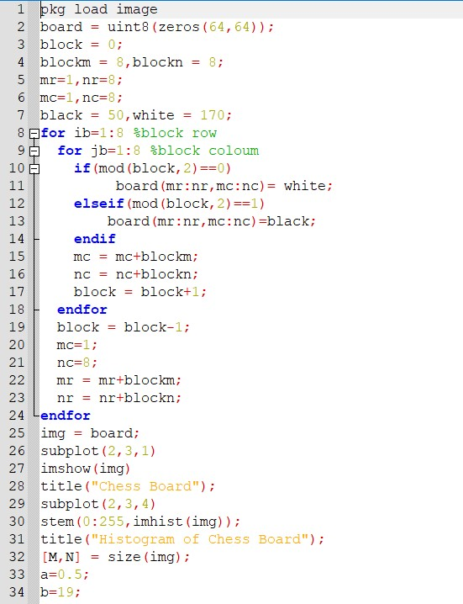

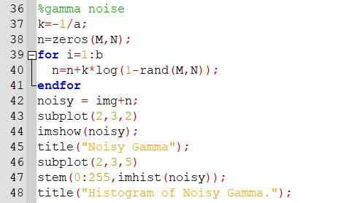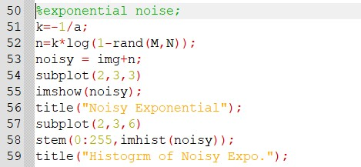

Output:

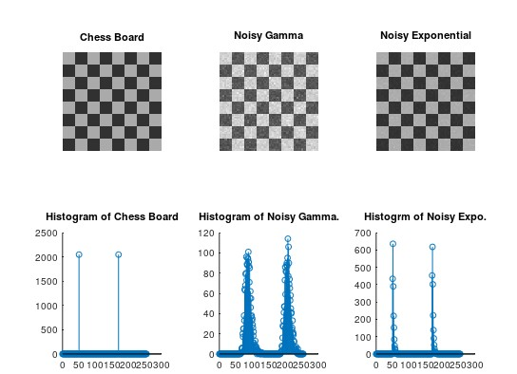

➢ After performing this exercise, we can conclude that both the noisy images have different histograms as per their characteristics.

1. **Take your Gray scale photo and generate noisy photo with:**

* **Gaussian noise with probability 0.4 using randn function.**

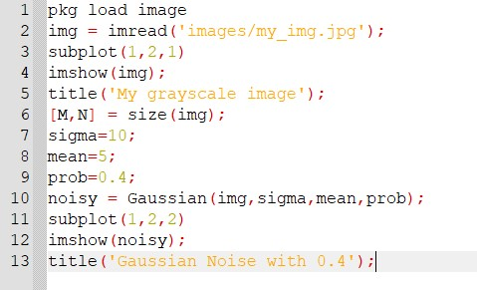

**Gaussian Function:**

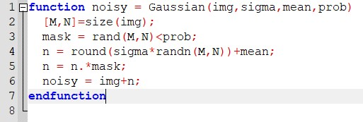

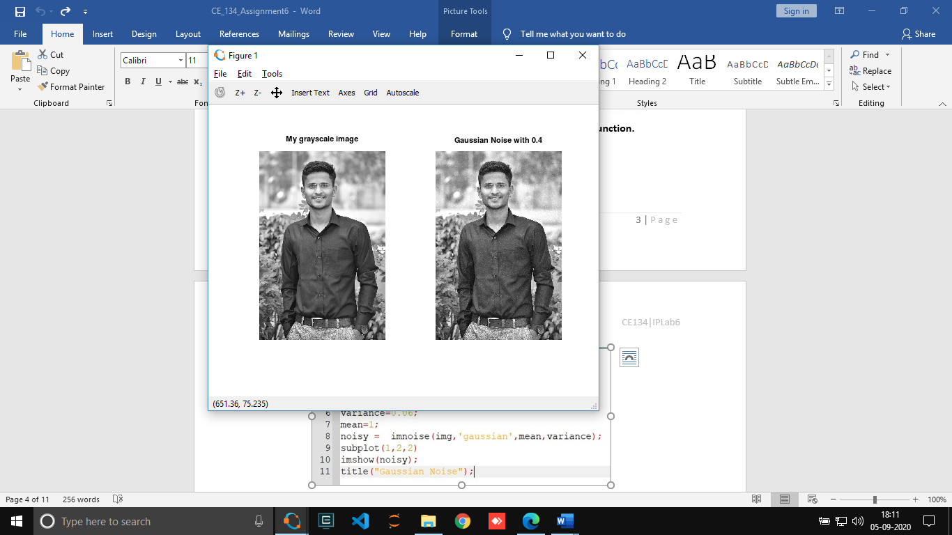

* **Gaussian noise with mean 2 and variance 0.06 using imnoise function.**

**Code:**

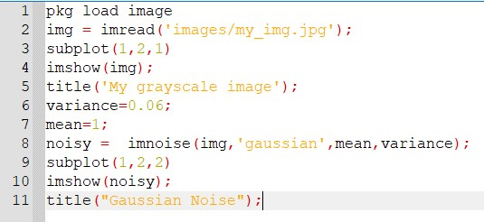

Output:

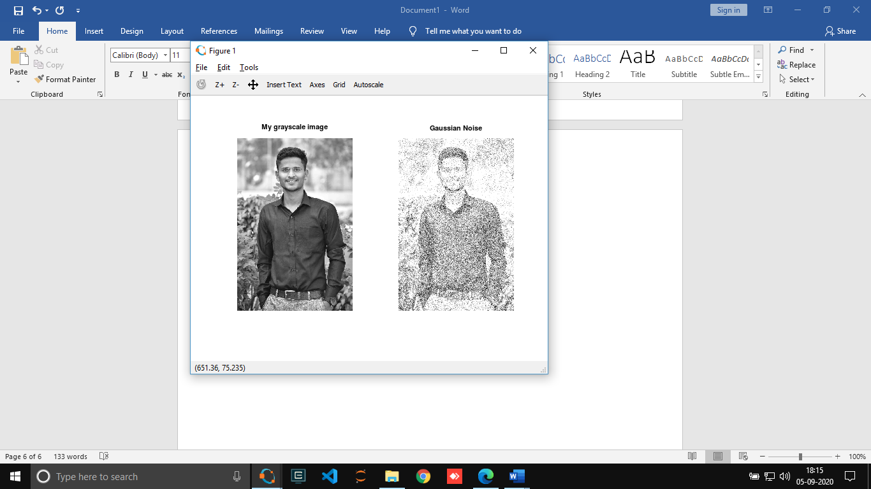

* **Salt and paper noise with probability 0.2 using your user defined function.**

**Code:**

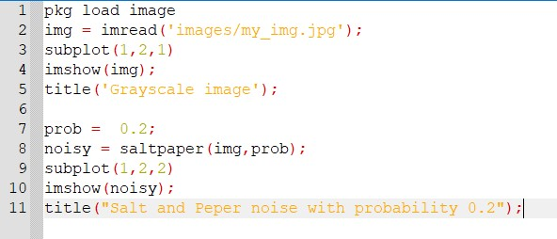

**saltpaper function:**

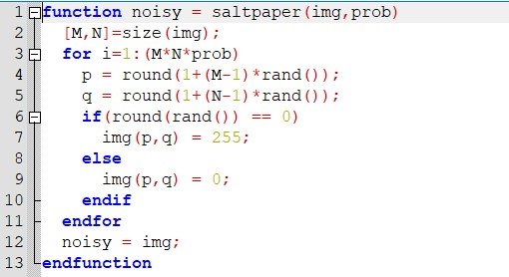

Output:

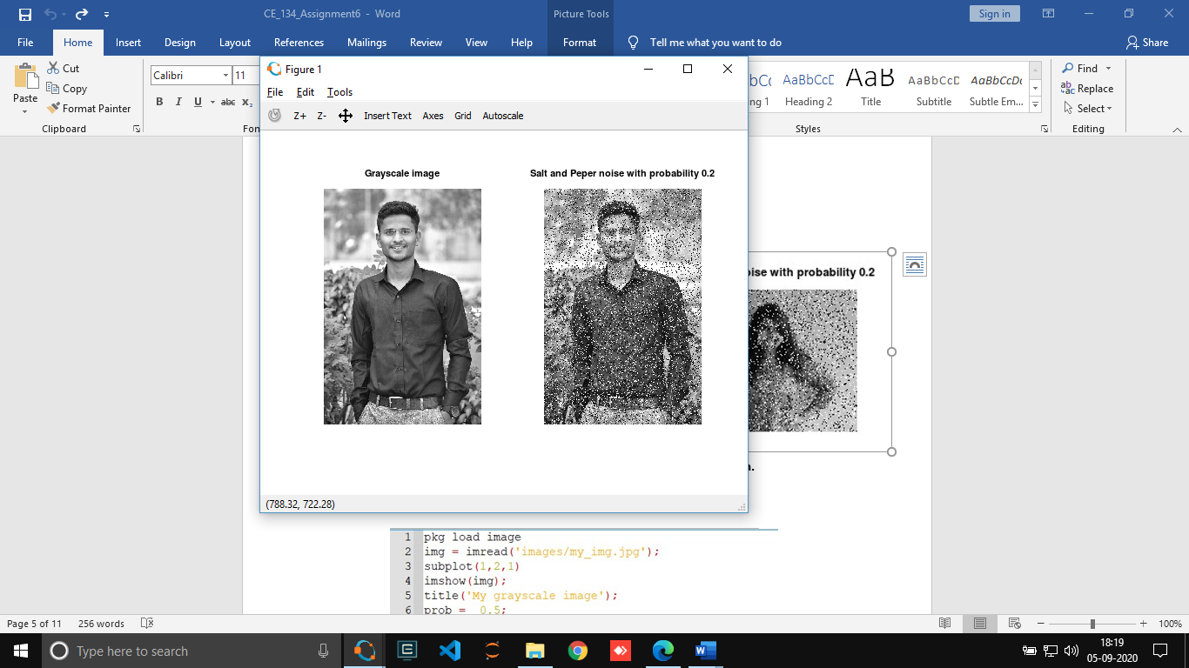

* **Salt noise with probability 0.5 using your user defined function.**

**Code:**

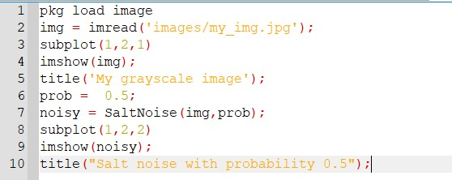

**SaltNoise Function:**

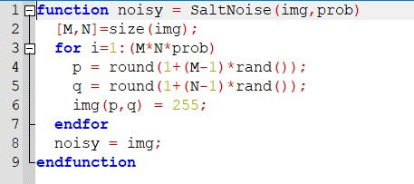

Output:

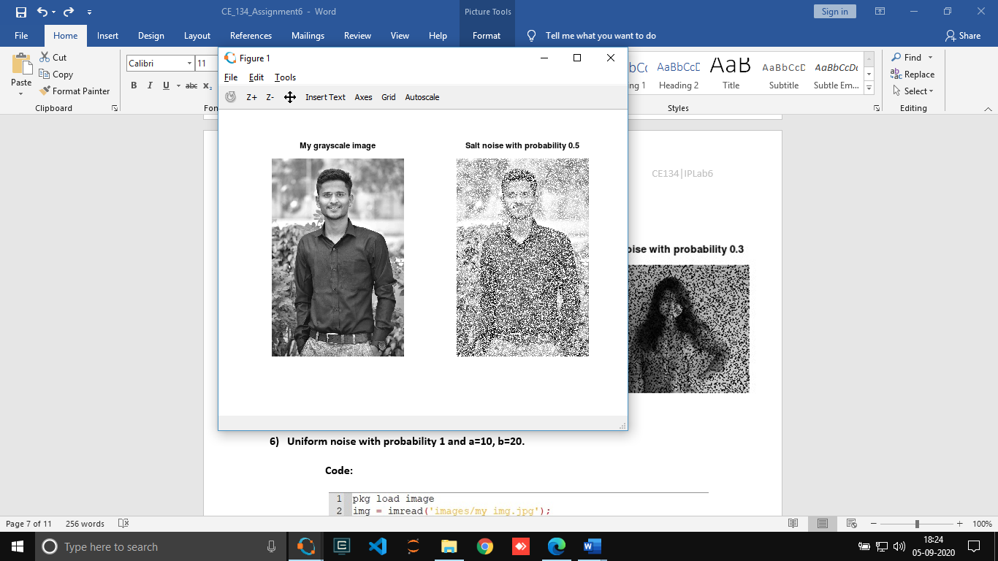

* **Pepper noise with probability 0.3 using your user defined function.**

Code:

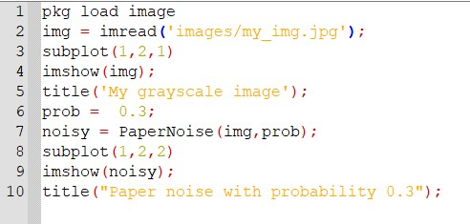

**PaperNoise Function:**

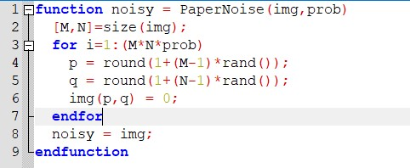

Output:

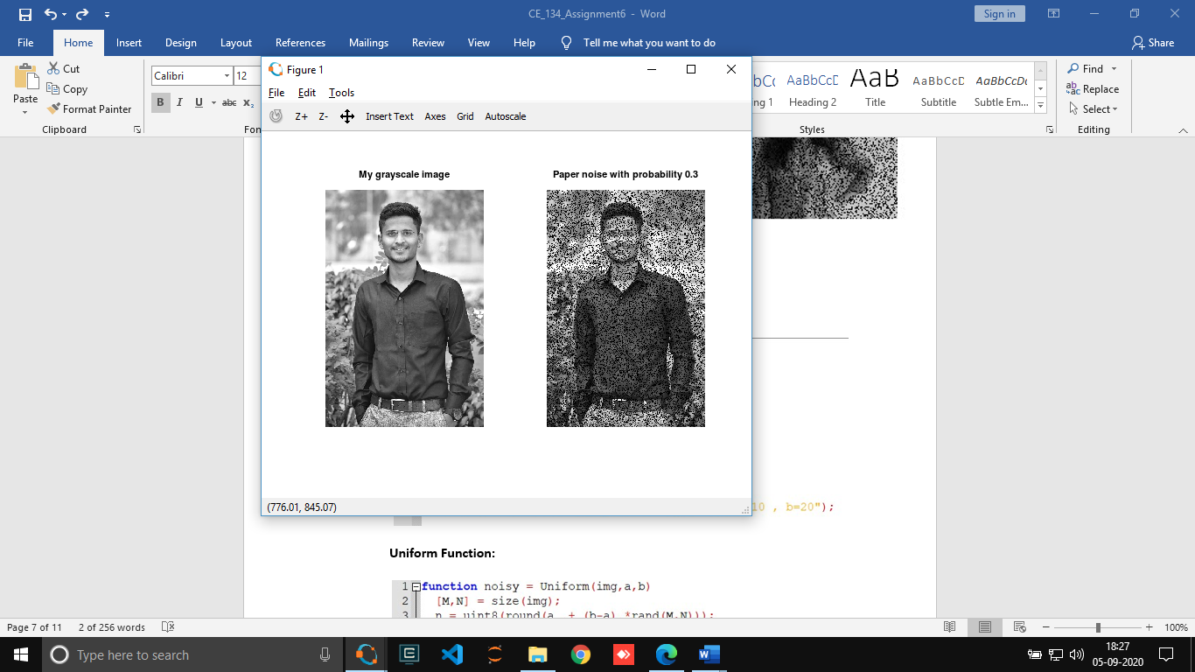

* **Uniform noise with probability 1 and a=10, b=20.**

Code:

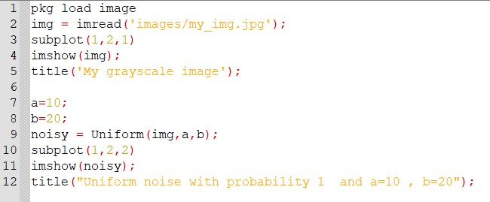

**Uniform Function:**

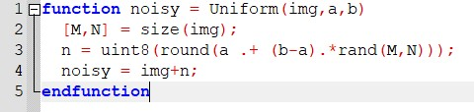

**Output:**

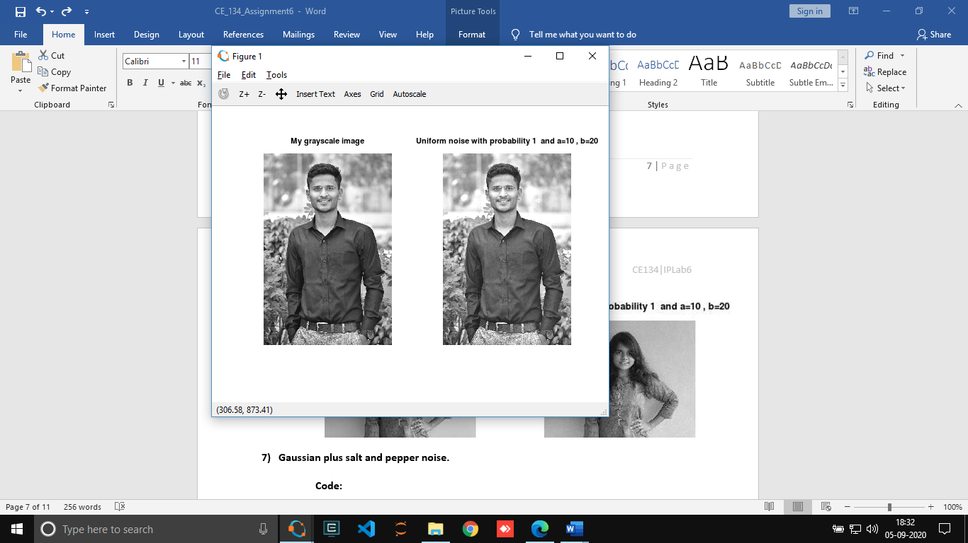

* **Gaussian plus salt and pepper noise.**

Code:

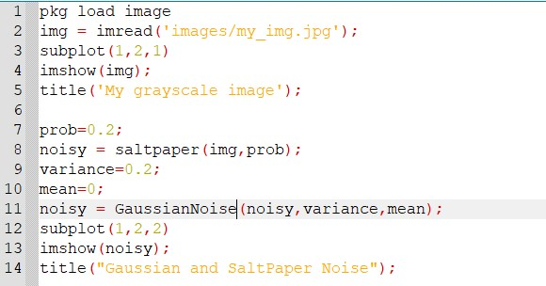

**GaussianNoise Function:**

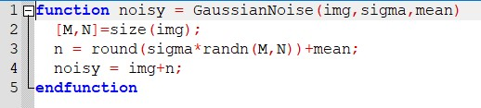

Output:

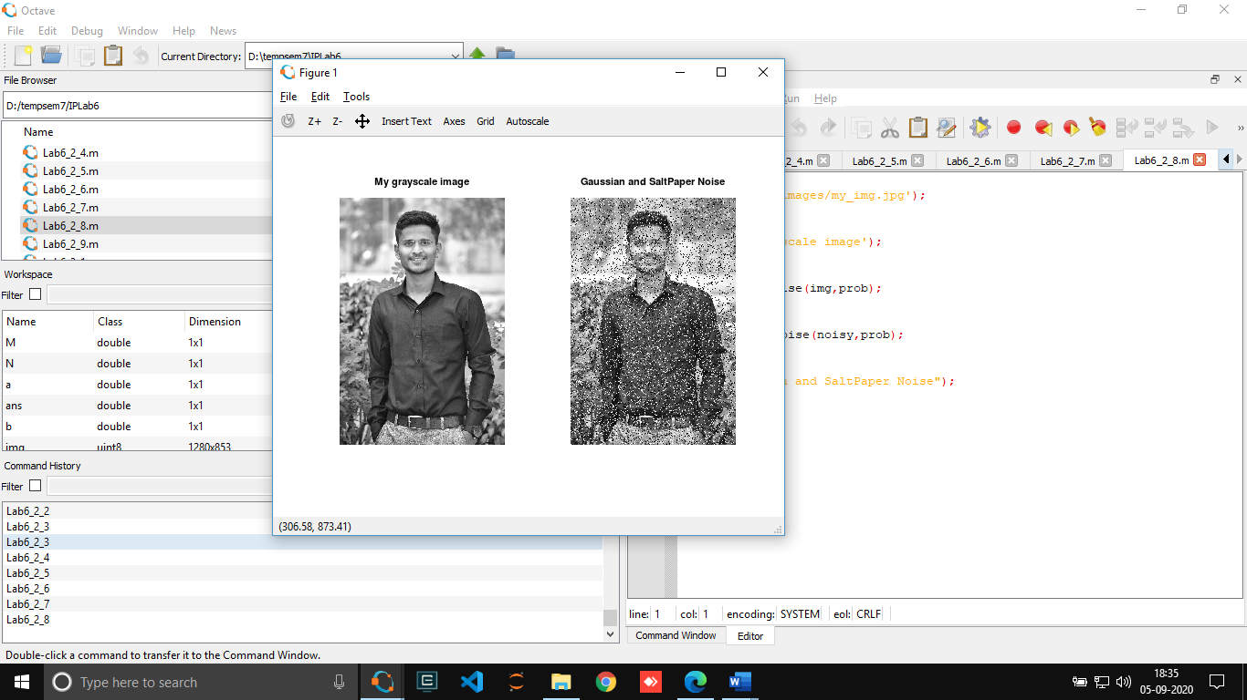

* **Salt noise with probability 0.3 and pepper noise with probability 0.2**

Cdoe:

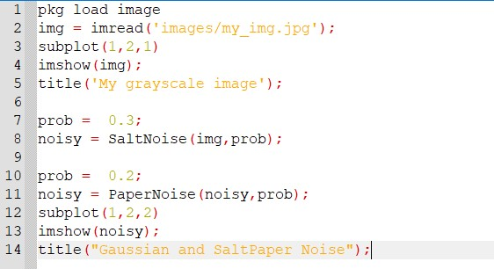

➢ SaltNoise and PaperNoise Functions are mentioned in above questions.

Output:

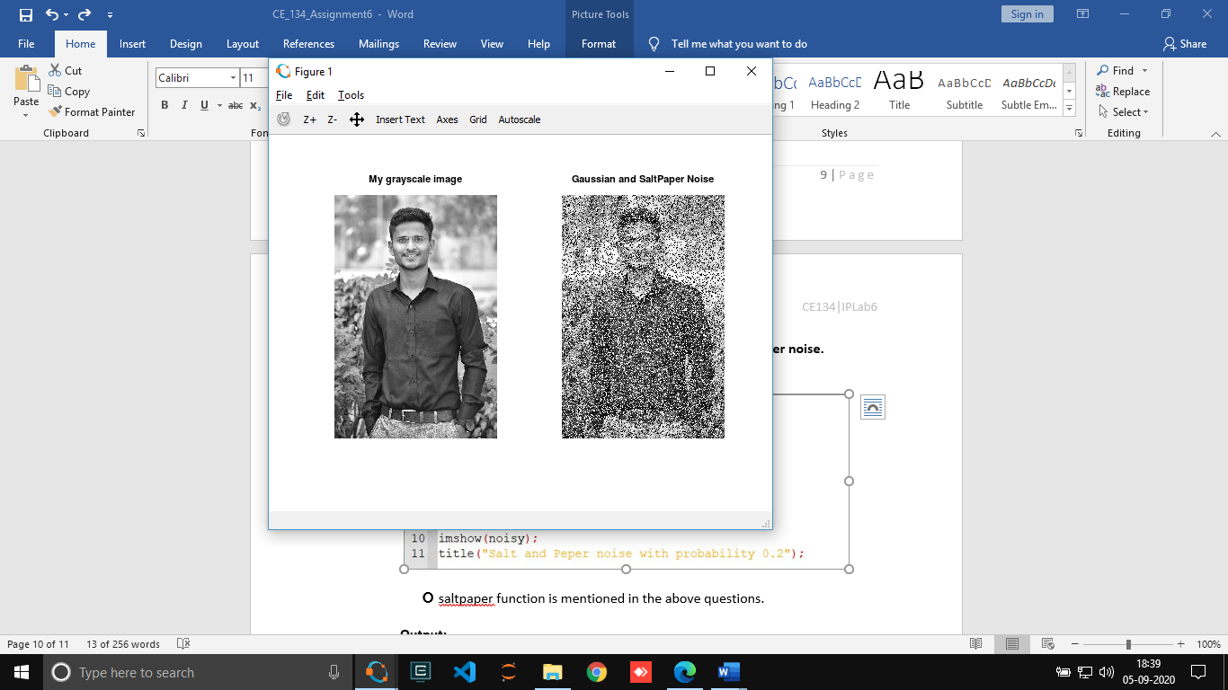

* **Salt and pepper noise with random probability of salt and pepper noise.**

Code:

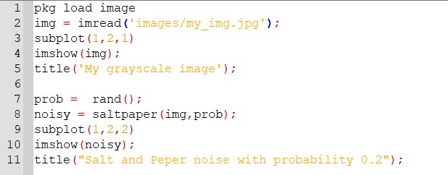

➢ saltpaper function is mentioned in the above questions.

**Output:**

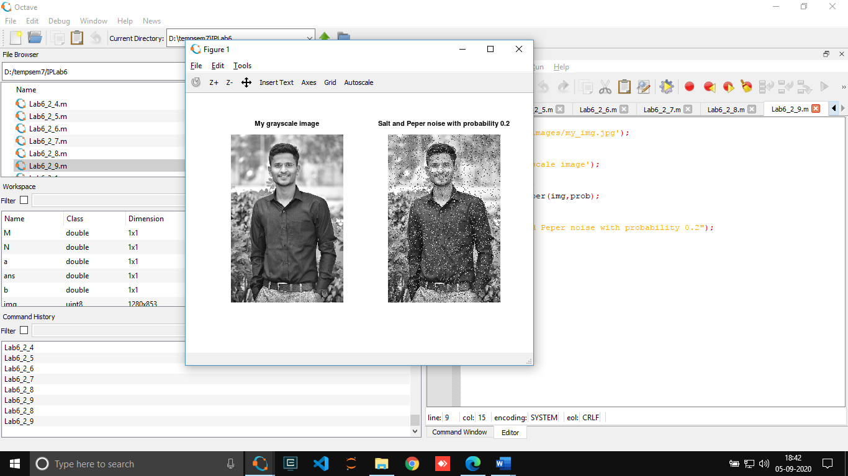

* **Get information about imnoise and generate various noisy images.**

**Code:**

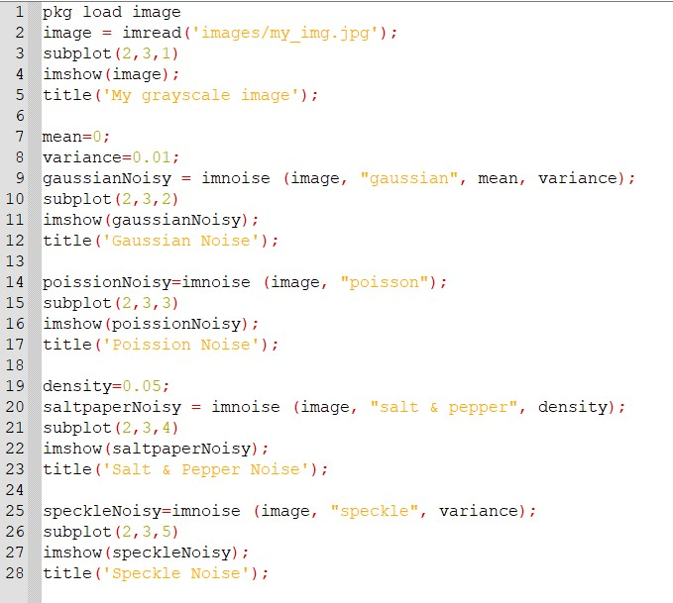

Output:

